Mux Files Given (Part I)

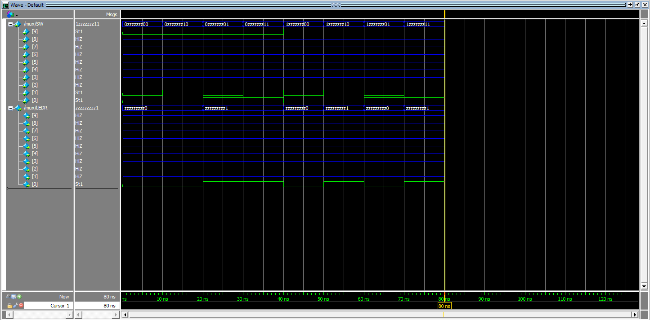

Mux using 7400s Chips (Part II)

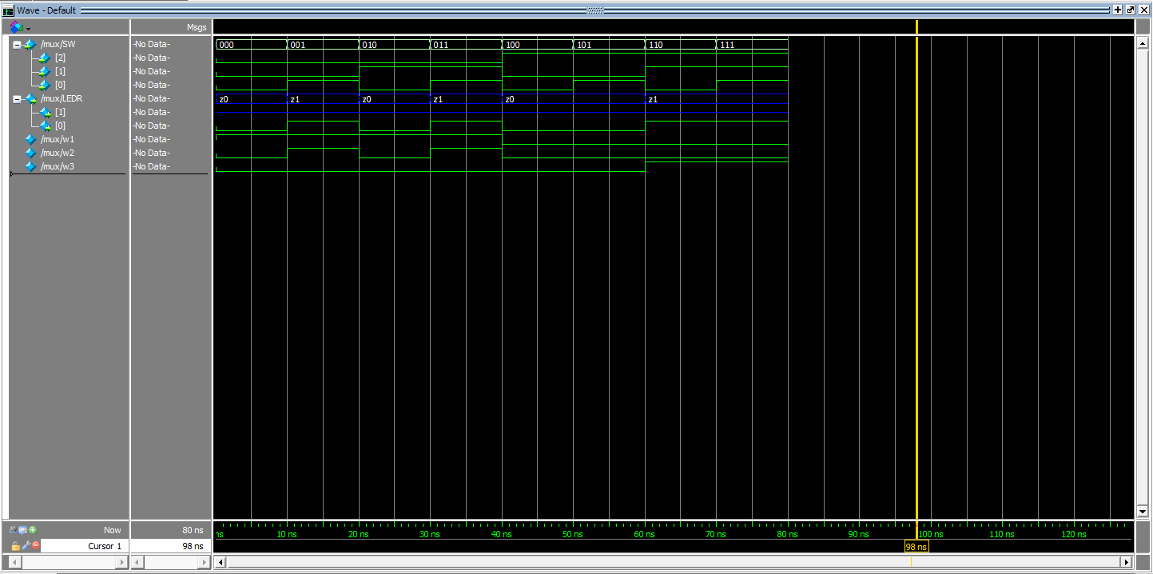

7404 (Part II)

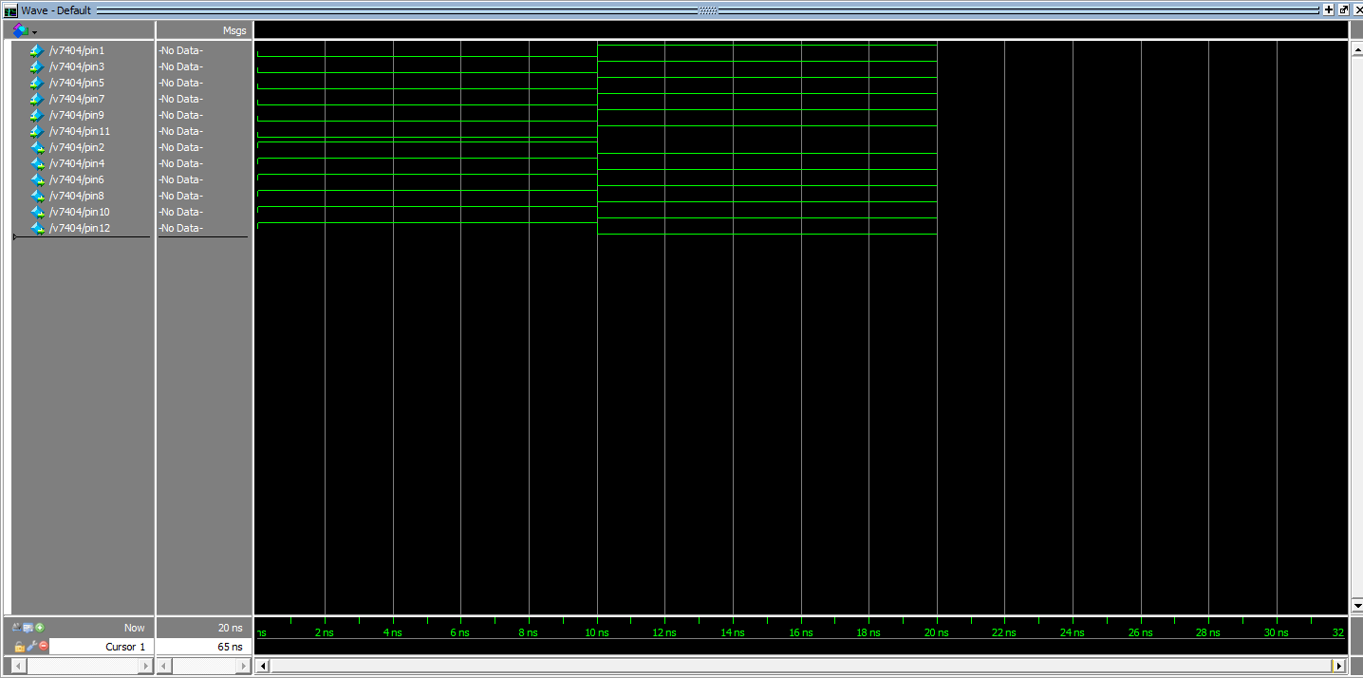

7408 (Part II)

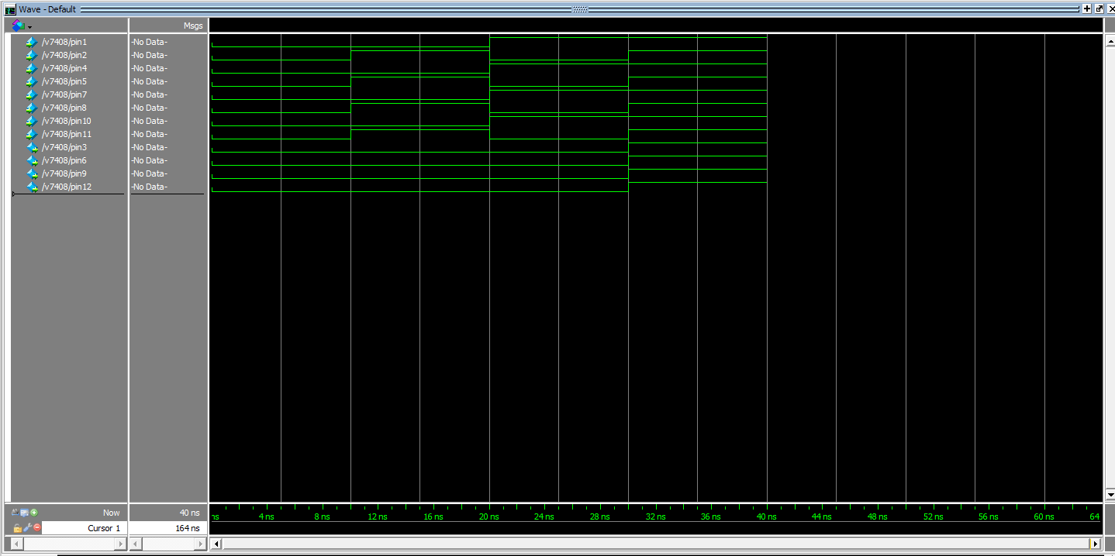7432 (Part II)

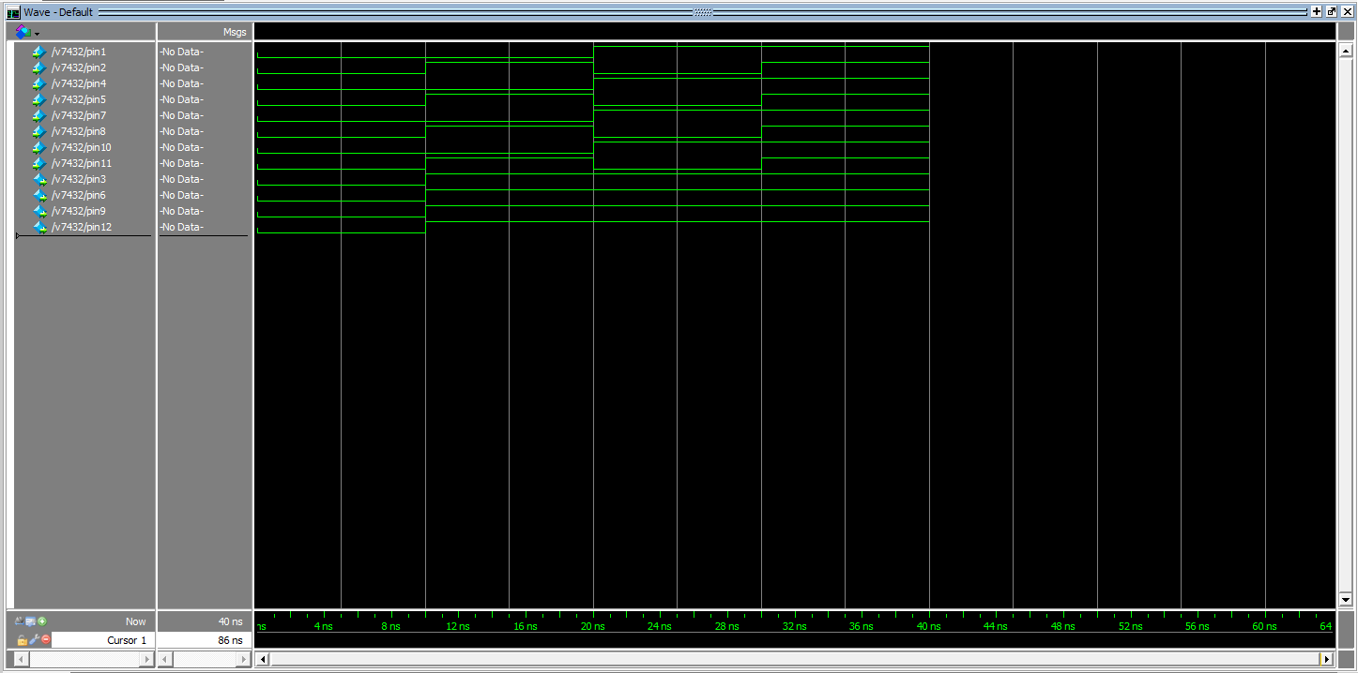

7-Segment HEX Display (Part III)

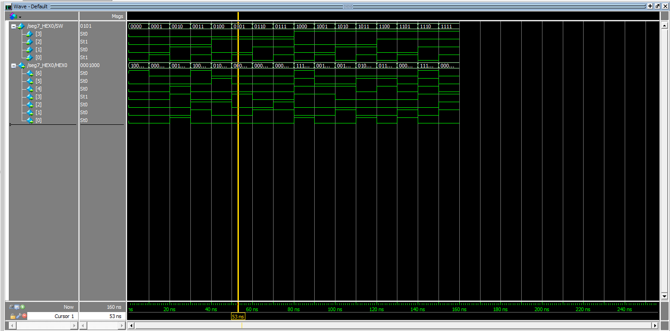

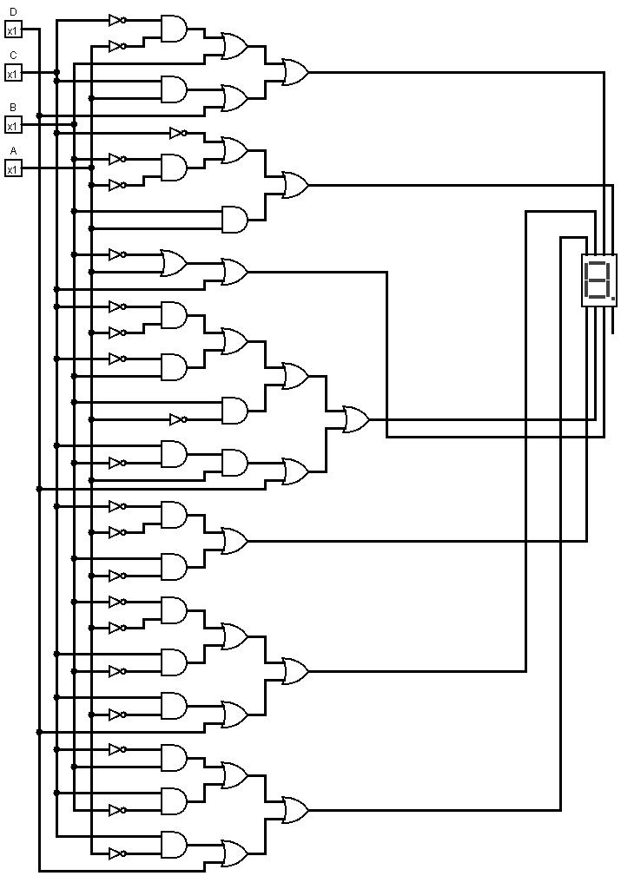

0 1 2 3 4 5 6

0 - 0, 0, 0, 0, 0, 0, 1

1 - 1, 0, 0, 1, 1, 1, 1

2 - 0, 0, 1, 0, 0, 1, 0

3 - 0, 0, 0, 0, 1, 1, 0

4 - 1, 0, 0, 1, 1, 0, 0

5 - 0, 1, 0, 0, 1, 0, 0

6 - 0, 1, 0, 0, 0, 0, 0

7 - 0, 0, 0, 1, 1, 1, 1

8 - 0, 0, 0, 0, 0, 0, 0

9 - 0, 0, 0, 1, 1, 0, 0

A - 0, 0, 0, 1, 0, 0, 0

b - 1, 1, 0, 0, 0, 0, 0

C - 0, 1, 1, 0, 0, 0, 1

d - 1, 0, 0, 0, 0, 1, 0

E - 0, 1, 1, 0, 0, 0, 0

F - 0, 1, 1, 1, 0, 0, 0